Movement Break
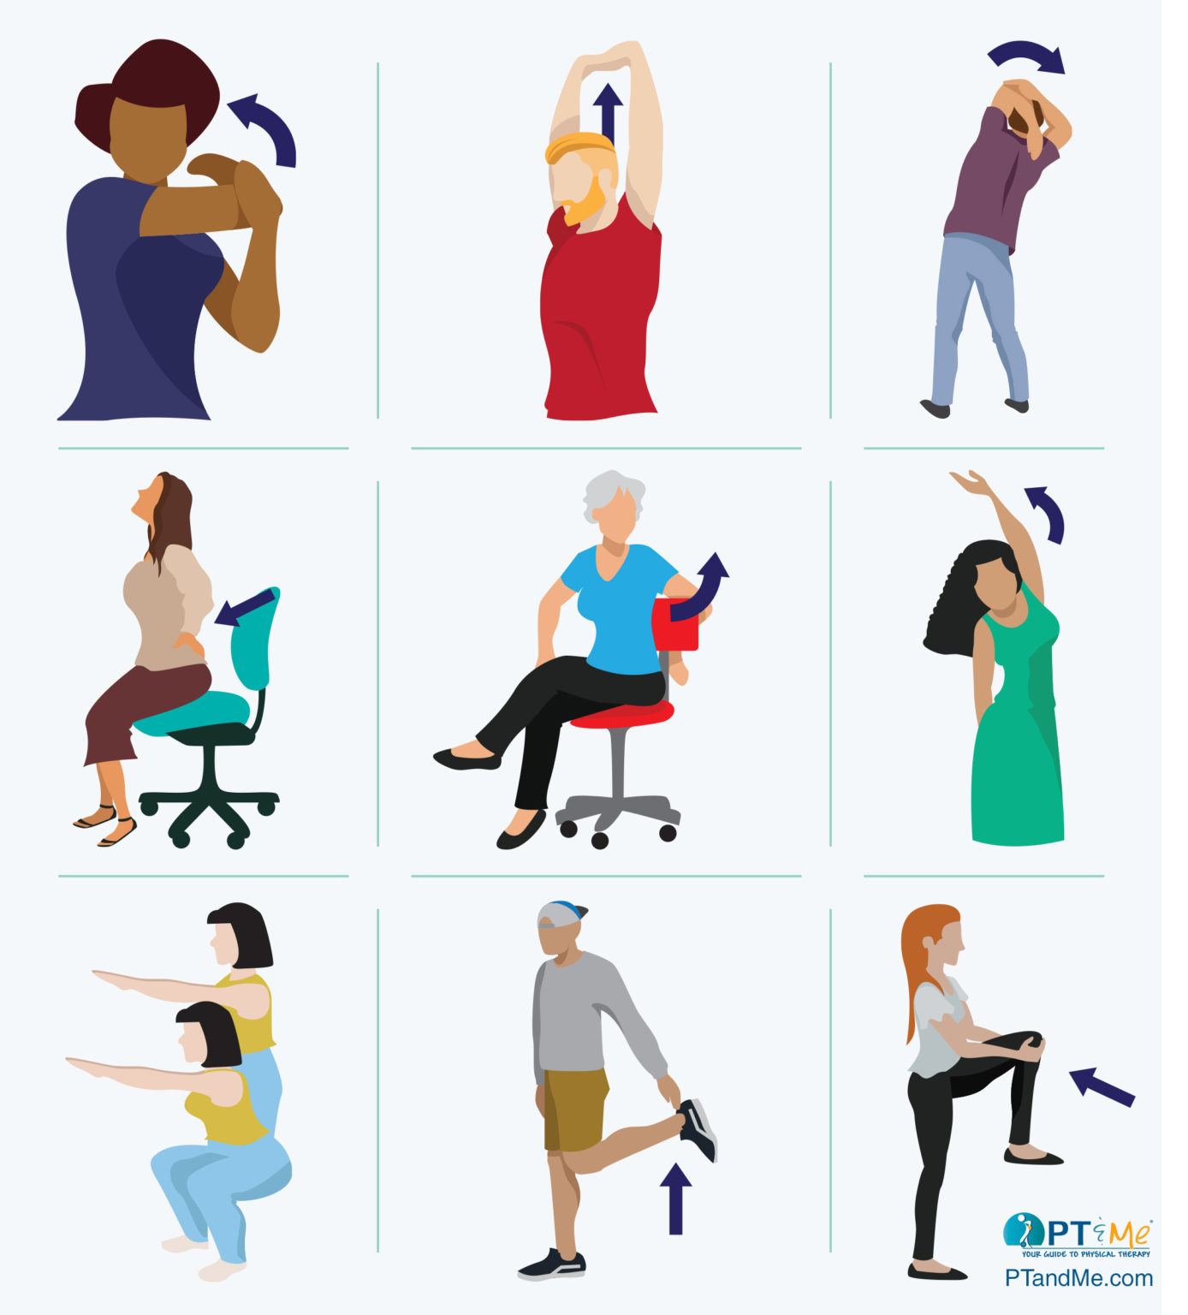
Other movement break ideas
March in place
Walk around house or school for 5 to 10 minutes after 50 minutes of studying or schoolwork

