Great Falls College MSU
Physical Activity & Nutrition
for Academic Wellness

- Physical activity enhances brain function and academic performance¹
- A healthy diet improves academic success such as earning a higher GPA²

Incorporate physical activity into your day:
- Park your vehicle further from the school’s entrance
- Walk for 10 minutes after 50 minutes of study/schoolwork
- Find fun YouTube videos that get your body moving: Heart Alchemy Yoga, POPSUGAR Fitness, Yoga with Adriene, Fitness Blender
- Stretch at your desk: see the ‘Movement Break’ handout

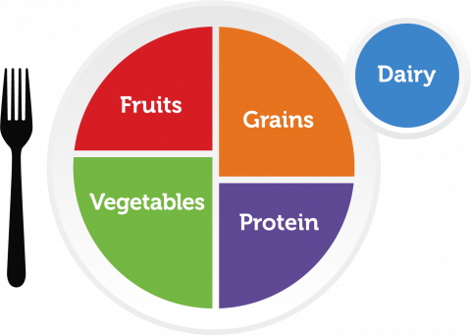
Make eating nutritious food easy:

Food group | Servings per day: women | Servings per day: men | Example
Fruit | 1.5 to 2 cups | 2 to 2.5 cups | 1 small apple = 1 cup
Vegetable | 2.5 to 3 cups | 3 to 4 cups | 2 medium carrots; 1 large bell pepper; 1 large sweet potato = 1 cup
Grains | 6 to 8 oz | 8 to 10 oz | 2” mini bagel; 1 slice of bread; 1, 6” flour or corn tortilla  = 1 oz equivalent
Protein | 5 to 6.5 oz | 6.5 to 7 oz | 1 egg; 1 oz cooked lean beef, goat, ham, or pork; 1 ¼  cups cooked beans = 1 oz equivalent
Dairy | 3 cups | 3 cups | 1 cup milk; 1 ½ oz hard cheese= 1 cup; 1 ¼ cups cottage cheese
https://www.myplate.gov/

- Visit myplate.gov (https://www.myplate.gov/)
  - What is on your plate? Learn more by completing
the ‘myplate quiz’
  - Find nutritious, easy meals (click on the ‘myplate kitchen’ tab then ‘recipes’)
  - Learn how to eat healthy on a budget (click on ‘eat healthy’ tab then ‘Healthy Eating on a Budget’)
- Quick nutrition tips:
  - Plan snacks and meals, Remember the food groups, Try new foods,
Drink more water, Try fruit for dessert
¹Haverkamp, B. F., Wiersma, R., Vertessen, K., Ewijk, H., Oosterlaan, J., & Harman, E. (2020). Effects of physical activity interventions on cognitive outcomes and academic performance in adolescents and young adults: A meta-analysis. Journal of Sports Sciences, 38(23), 2637-2660. doi:10.1080/02640414.2020.1794763
²Whatnall, M. C., Patterson, A. J. Burrows, T. L., & Hutchesson, M. J. (2019). Higher diet quality in university students is associated with higher academic achievement. Journal of Human Nutrition and Dietetics, 32, 321-328. Retrieved from: https://doi.org/10.1111/jhn.12632

