Great Falls College MSU
Organization for Academic Wellness

- Life Balance: a satisfying blend of occupational (including school and work), familial, social, and leisure pursuits
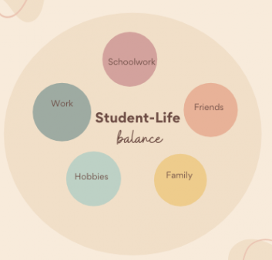
- Organization enables life balance

Is your life balanced?
- Wellness Wheel
- Life Balance Inventory
minerva.stkate.edu/LBI.nsf
How are you spending your time?
- Weekly Plan Outline
Learn to be efficient:
- Complete the ‘Note Taking,’ ‘Test Taking Strategies,’ and/or ‘Reading Skills for Learning’ modules within the ‘Student Success Course’ on D2L
How to organize your life:
- Create a to-do list
- daily, weekly, monthly, and/or
8-week block
- List tasks in order of highest to lowest priority
- Place to-do list in a highly visible location (e.g., on your refrigerator door)
- Use a planner
- Review upcoming due dates, activities,
appointments, etc. at the beginning of each week
- Declutter once a week
- Get rid of documents (physical or on your computer)
that you no longer need
- Dedicate a study space
- Free of distractions (magazines, leisure books,
games, phone, people, pets)
- Comfortable desk set-up (power zone = relaxed wrists
elbows at 90, feet flat on floor, items (such as a keyboard)
kept close to your body)

