Great Falls College MSU
Mindfulness & Sleep
for Academic Wellness
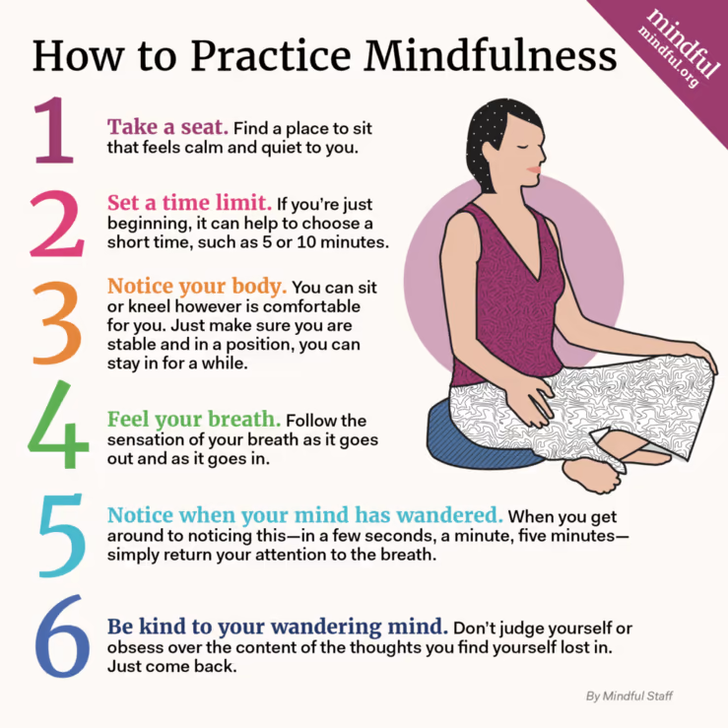
Mindfulness:
- being fully present
- aware of where you are
- aware of what you’re doing
- not overly reactive
- not overwhelmed by your
environment

Benefits of being mindful:¹
- less stress
- ability to concentration
- improved sleep quality
- higher test scores
- better life balance
- health
- higher quality of life

Mindfulness Apps (see “Mindset
& Emotion for Academic
Wellness” handout) *More information at mindful.org

Visit korumindfulness.org explore mindfulness under ‘resources’ tab

Sleep:
Sleep hygiene: optimizing your bedroom environment and daily routines to promote
good quality sleep
Habits: specific, automatic behaviors
Routines: sequence of daily events that provide daily structure
- Daily and nightly routines facilitate habits that can improve sleep quality

Create a sleep environment:
Comfortable mattress & pillow | Temperature set around 65⁰F | No light: use curtains or eye mask
No noise: earplugs, white noise machine, fan | Try scents: lavender may induce calmness | Pets off the bed or outside of the bedroom

Create a nighttime routine: (see ‘Routines for Quality Sleep’ handout)
- Keep routine consistent

More information can be found at sleepfoundation.org
¹Seo, B., Thomas, A., Corcoran, S., & Enam, N. (2020). Mindfulness workshops to address stress and quality of life in college students. SIS Quarterly Practice Connections, 5(4), 20–22

