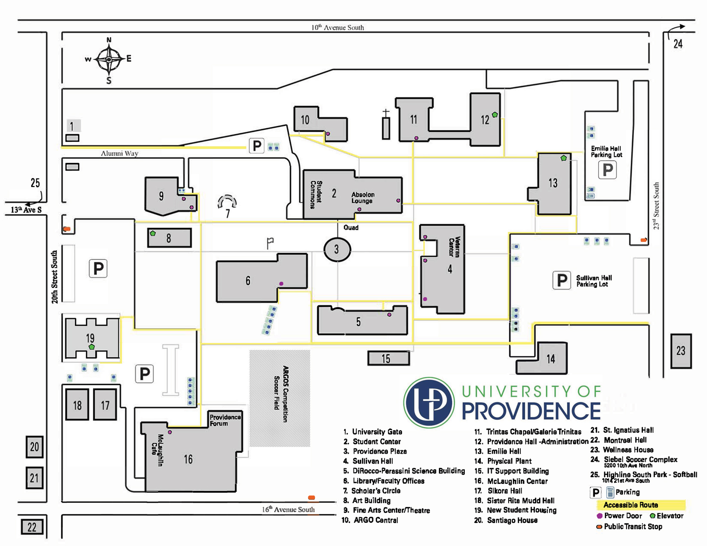

P

**MSU GFC Parking Map**

Blue is the available parking lots

And additional parking at MSU GFC